Revolution Rides on Railroads:
Transportation Network and Diffusion of Protests
during The March First Movement in Colonial Korea, 1919

Duol Kim
Department of Economics
Myongji University
duolkim@mju.ac.kr
(Update: May 23th, 2018)

Abstract

The March First Movement in 1919 was the massive protest towards national independence in colonial Korea. I explored the role of railroad networks on the diffusion of demonstration and found that regions with railroad stations have larger number of gatherings, more participants, and more vehement protests that resulted in larger number of arrests. The Japanese colonial government had built railroads to exploit benefits from Korea, but this had brought a rather ironical result, that is, spreading and strengthening protests against their colonial rule.

Acknowledgement: I am grateful to Heon-ju Chung for his devotion to data collection. Earlier version of this paper was presented at Applied Economics Association. I appreciate Sok Chul Hong and other participants for helpful comments.
1. Introduction

Imperial forces of the modern period had conquered various parts of the world, colonized the regions, and ruled the natives. The colonizers didn’t allow political rights of the indigenous people in most cases. However, this suppression and discrimination ironically forced the colonial people to realize their conditions and made them fight for national liberation and democracy. Analyzing how the political consciousness of colonial people had evolved through their struggle during the colonial era is critical to understand the formation of political structure after liberation and ultimately post-colonial economic performance of developing countries.
The March First Movement (Samil Undong) of Korea who was a colony of Japan from 1910 to 1945 can shed a light on this research agenda. In March 1st, 1919, thirty-three national representatives announced the Declaration of Independence against Japanese occupation. Crowds gathered and marched in downtown Seoul afterwards, and despite brutal suppression more than a thousand demonstrations with large participants occurred at almost every part of Korean Peninsula for two months. The March First Movement was a beginning of systematic efforts toward national independence, and this historic event became the spiritual foundation of the nation-building after the liberation in 1945. It also had an influence on national independence movements of neighboring countries including May Fourth Movement in China.
Numerous scholars have examined causes, processes, and aftermath of the March First Movement since it occurred. Whereas earlier studies focused on nationwide general patterns and examined what happened in Seoul or what national leaders thought or did, many recent works have anatomized demonstrations at town- or village-level. These micro-analyses have revealed diversity of the March First Movement and enhanced our knowledge, but more efforts should be made to integrate the macro- and micro-level findings. Statistical analysis can be useful for this purpose, that is, to understand how incidence, intensity, and duration of demonstrations differed across the regions, and what determined general patterns and regional variations.
In this paper, I explored transportation cost as a major determinant of regional variations of protests. Various evidence suggests that leaders of local demonstrations came to Seoul, joined the demonstrations on March 1st, met the leading group, and then came back to their hometown and organized protests. This implies that regions with cheaper or easier access to Seoul had more demonstrations.
In this regard, I examined correlation between existence of railroads and incidence of demonstrations and found that regions with railroad stations had more gatherings, more participants, and more vehement protests that resulted in larger number of arrests. The Japanese government had made large investment on railroads since 1900 to exploit benefits from Korea, but this had caused an unexpected side-effect, that is, to enhance people’s national consciousness and to promote protests to their colonial rule.
Railroads has been one of the key subjects in economic history for a long time. Scholars have examined how much railroad contributed to economic growth and what the mechanisms were. Although transportation networks like railroad could contributed also to political development, less attention has been drawn on this aspect. This study contributes to broadening our perspective.
In the following discussion, I will first briefly review the history of March First Movement (section 2) and railroad construction in colonial Korea until early 1919 (section 3). Then, I will examine how railroad contributes to the March First Movement in two ways. First, I will estimate the correlation between railroads and level of protests across regions (section 4). Second, I will figure out whether regions with railroads had demonstrations earlier than those without railroad (section 5). The last section will summarize the results and conclude (section 6).

2. The March First Movement

After the collapse of Koryo Dynasty (918-1391), Chosun Dynasty (13912-1910) ruled Korean Peninsula for almost six hundred years. However, since the port-opening from 1876 by the pressure of Japan and Western countries, they were not successful in reforming themselves, and Korea was finally annexed to Japan in 1910. In order to remove protests against Japanese rule, the Governor General of Colonial Korea deployed military polices all over the country, put Korean political leaders into prison, closed Korean newspapers, and deprived of any political rights from Koreans.
Oppressive policies, however, could not discourage Korean people permanently. In late 1918 and early 1919, a new wave of resistance sprouted. The principle of national self-determination proposed by President Woodrow Wilson of the United States inspired national leaders. Domestically, Emperor Kojong passed away in January, 1919, and his sudden death made Korean people suspect that he was poisoned by colonial government who feared that King Kojong tried to organize independence movement secretly. The date of state funeral was decided as March 3rd, and large number of people from all over the country came to Seoul for mourning.
Leaders of Cheondokyo (a Korean national religion), Christianity, and Buddhism decided to use this event for a large-scale demonstration requesting independence of Korean nation. They planned to utilize their believers and organizations all over the country to propagate the Declaration of Independence and organize local protests. Large number of students volunteered to collaborate with the religious groups.
Finally, at noon, March 1st, 1919, the thirty-three national representatives who were leaders of Cheondogyo, Christianity, and Buddhism announced the Declaration of Independence at a restaurant in downtown Seoul. Thousands of people gathering at the center of Seoul marched streets, and similar demonstrations were held in six cities at the same day. Then, students and activists went to various parts of Korea, delivered leaflets, advertised what happened in Seoul, and led local protests.
Local demonstrations were generally peaceful at the beginning. Crowds gathered at public places such as markets, announced Declaration of Independence and marched the street. For avoiding deterrence of police, people often marched or shouted at the hill near villages in the night with torches. Merchants showed their supports by closing their shops. Students boycotted classes. Many Korean civil servants resigned and joined the demonstrations.
An official document by Governor General reports that 1,152 demonstrations occurred by the end of April and that 550 thousand people participated in the demonstrations (Table 2-1). Considering that the total population of Korea at this time was about twenty million and that official documents were likely to drop small protests, the level of participation was surprisingly high. Demonstrations occurred or planned but failed due to detection in 210 Kuns out of 232, implying that the demonstrations occurred at least once in every part of Korean Peninsula.

Table 2-1. Basic Statistics of the March First Movement, March 1st to April 30th, 1919.
 | Pattern of Protests |  |  | Total
 | Violent | Peaceful | Unsuccessful due to Detection
Protests | 319 | 496 | 337 | 1,152
Participants | 305,888 | 241,591 | 750 | 548,229
Arrested | 6,687 | 5,751 | 6 | 12,444
Injured
Civilian | 1,188 | 34 | 1 | 1,223
Police | 2 | 1 | 0 | 3
Dead
Civilian | 497 | 7 | 0 | 504
Police | 68 | 0 | 0 | 68

Sources: Chosen Military Police Headquarters and Police Department of Chosen Governor General (1920)

Governor General reacted to these protests aggressively from the very beginning. They arrested the thirty-three representatives right away, and they tried to disperse the crowds by beating them or even shooting guns. Protesters reacted violently by throwing stones to police or attacking public offices. Large number of participants were wounded and even died. Arrested participants were tortured and sentenced to prison. However, this harsh suppression could not break up the wave of protests for a long time.
Although the flow of demonstrations was mostly calmed down by the end of April, these massive protests had profound long-run impacts. Inspired by this experience, people tried various forms of independence movements. At the same time, the national leaders of independence movement established the Provisional Government of the Republic of Korea at Shanghai, China in 1920. Many people went to Manchuria and organized armies for national independence. Until the liberation in August 1945, these organizations worked as vehicle for the national independence movement.
The March First Movement forced Japanese government to change their colonial policies as well. They realized that oppressive military policies would not work and took a conciliatory strategy. Military police was replaced by the civil police. They allowed Korean newspapers and lowered level of censorship on publications to some extent. From 1920, they started municipal elections. Korean people paying certain level of tax could be candidates as well as voters.
In the long run, the collective memory of this massive movement awakened people. Efforts towards national independence continued both in and out of colonial Korea, and they contributed to independence. Ultimately, this colonial experience became the foundation of nation-building after 1945.

3. Railroad and Geographical Distribution of Protests

From March 1st to the end of April, demonstration occurred at almost every part of Korean Peninsula. However, incidence or intensity of protests differed across regions significantly. Figure 3-1 shows regional distribution of demonstrations, and two things are noteworthy. First, demonstrations were concentrated in Kyungki-do, the province (Do) at the central-western part of Korean Peninsula. As Seoul is located at the center of Kyunggi-do, this geographical pattern implies that demonstrations occurred more intensively in regions around Seoul. Second, if we look at the other parts, demonstrations were still widely distributed to all over the country. A question is what determined this distributional pattern.

Figure 3-1. Incidence of Demonstrations in the March First Movement, March 1st to April 30 st , 1919
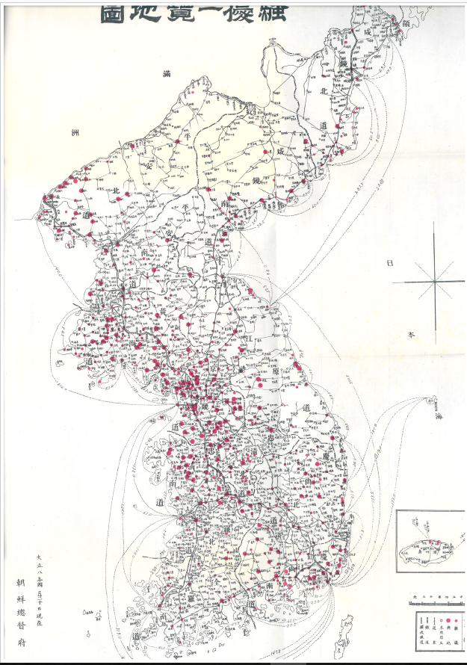
Source: Governor General of Colonial Korea (1919)

Transportation cost can be a usual suspect for resolving this problem. As mentioned earlier, interaction with Seoul leaders was critical for diffusion of local demonstrations. This implies two things. First, the nearer a region would be to Seoul, the more the region could have. Second, even if a region is far from Seoul, if transportation to Seoul was cheaper or easier, the region can have more information and more direct interaction. This implies that transportation network rather than physical distance matter for explaining distribution of demonstrations.
Railroad should play an important role in this context. After the port-opening in 1876, foreign investors were interested in building railroads in Korea. They competed for getting patents to build railroads from Korean government, but Japanese government finally obtained it and built the Kyungin Line, the first line that linked Seoul and Incheon (Figure 3-2). Since then the Japanese government and successively the Governor General planned and built railroad networks until the end of the colonial era. Although Japanese private railroad companies built some lines, all the major lines were constructed and operated by colonial government monopolistically.
In the 1900s and 1910s, Japanese government focused on building four core lines that became the backbone of the Korean railroad system. The Kyungbu line connected Seoul and Busan. Busan was the largest port located at the southeastern part of Korean peninsula, and it was the maritime gateway between Korea and Japan. The Kyungui line linked Seoul and Sinuiju. Sinuiju is the border city at Yalu river, located at the northwestern part of Korean Peninsula. The two lines together accommodated transporting men and materials from Japan to China via Seoul.
Adding to these lines, two more branch lines were built in this period. Honam Line went to southwestern part of Korean Peninsula. The Southeastern region is the largest plain in Korea, and this was used to move cereals to other parts of Korea. Last is Kyungwon Line, and this linked Seoul to Wonsan, a major port of the northeastern region.

Figure 3-2. Railroad Network of Colonial Korea, c.1919.
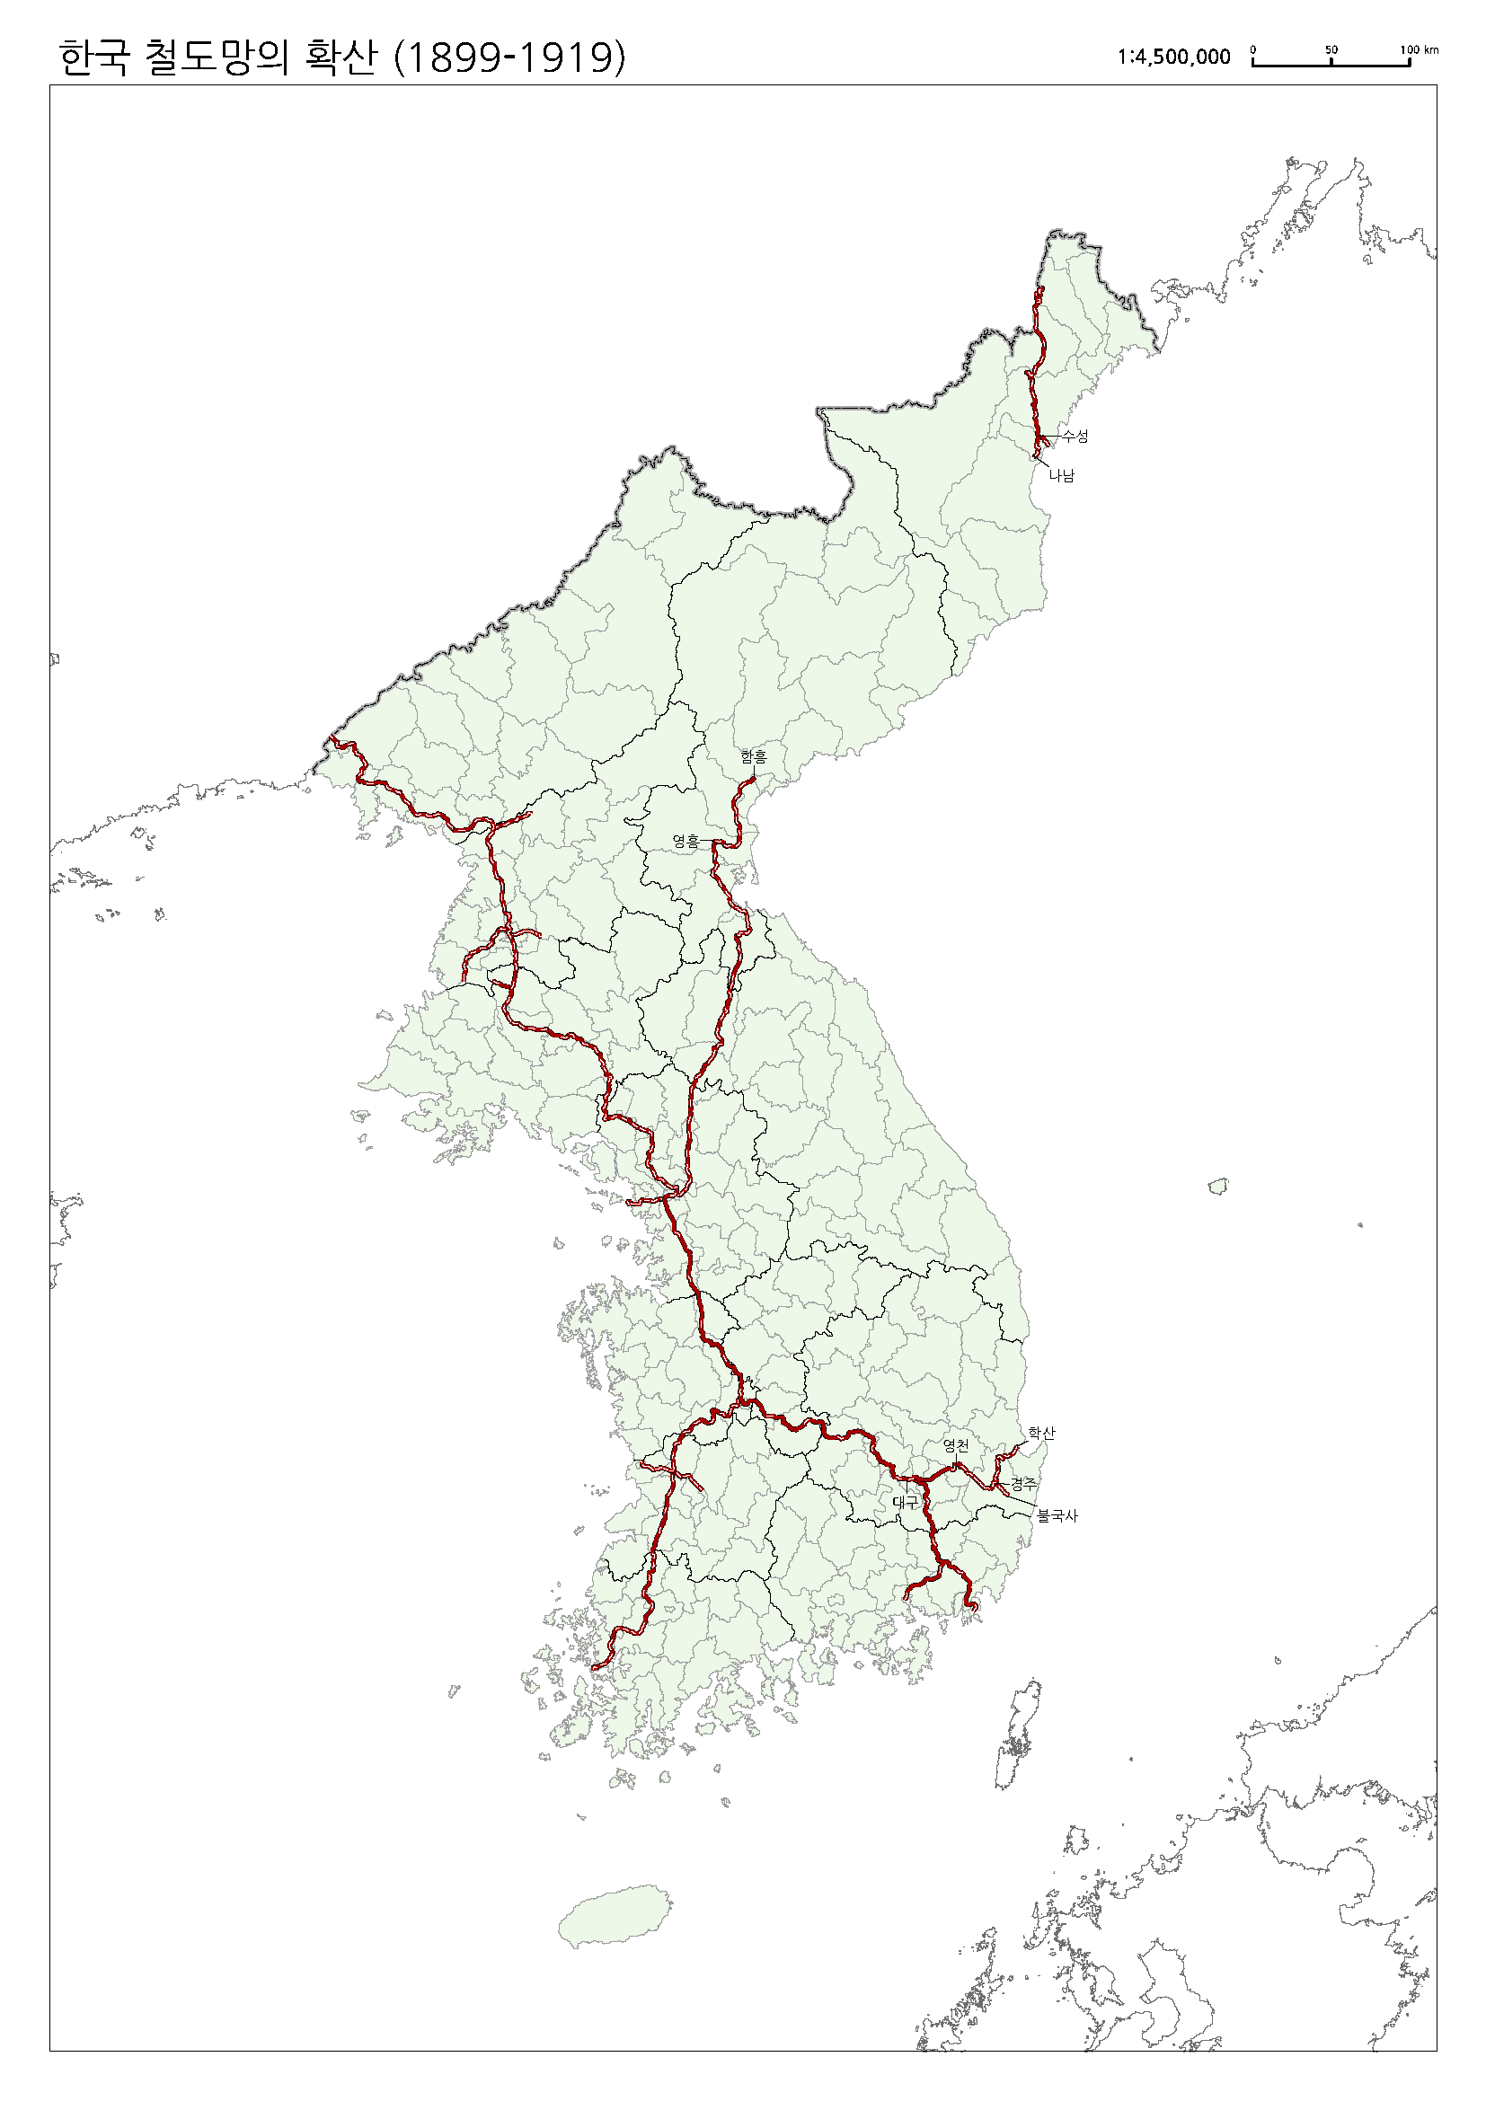
Source: Resource Institute of Korean Studies, Korea University

On the eve of the March First Movement, construction of the four core lines was almost completed. As shown in Figure 3-2, the railroad department almost completed X-shape basic structure and they were ready to stretch out branch lines. Out of 232 Bus (cities) and Kuns, about 60 had railroad stations at this time.
Scholars recognized the role of railroad networks to diffusion of the March First Movement. For example, Kim (2000) mentioned that this railroad networks played a key role for the propagation of protests all over the country. However, no one have shown evidence confirming this possibility. At the same time, he didn’t explore the confounding factors. The following analysis is to examine systematically the impact of railroads on the success of the March First Movement by estimating correlation between them.
Railroad increased the speed of movement and enhanced connectivity between these regions significantly. The goal of constructing railroad network was definitely to get economic benefits and to rule Korea efficiently. However, this should also accommodate mobility of people and information, and it should enhance people’s political consciousness and ultimately explosive propagation of the March First Movement.

4. Railroad and Regional Distribution of Protests: Statistical Analysis

The impact of railroads on the spread of demonstrations can be examined in two ways. First, we can explore cross-regional pattern. If railroad matter, regions with railroad connection should have more demonstrations and more participants. Second is chronological pattern. If the demonstrations diffused from Seoul to regions with railroads and then to other regions, we can expect that regions with railroad connection should have demonstrations earlier than those without connections.
I first investigate the cross-regional pattern. I used information in the Table of Chosen Riots. This data was collected and published by Police Department of Governor General and Headquarter of Chosen Military Policy right after the end of the March First Movement. They listed gatherings comprehensively and their important information such as the date and place of gathering, the number participants, the number of arrested, wounded and dead, and so on.
Table 4-1 shows the basic statistics. Demonstrations occurred or were attempted at least once at 201 out of 220 Kuns. In these regions from March 1st to April 30th, 7.5 demonstrations occurred, 2,841 people participate per protest, and 56.9 out of them were arrested on average.

Table 4-1 Pattern of Demonstrations according to Railroad Connections
 | rail | No rail |  |  | total
 |  | Total | neighbor | non
Number of Districts | 58 | 162 | 61 | 101 | 220
Occurrence (sum) | 55 | 138 | 53 | 85 | 193
demonstrations (mean) | 11.5 | 5.9 | 7.3 | 5.0 | 7.5
participants (mean) | 4493 | 2182 | 3181 | 1559 | 2841
arrested (mean) | 95.4 | 43.1 | 41.1 | 44.2 | 56.9

Sources: See the text.

Yearbook of Railroad Department of Chosen Governor-General and Tables of Distance between Do, Bu, Myon of Chosen include information on railroad station and their location. Using this, I identified whether a Kun has railroad stations (Rail) or not (No Rail). In case of No Rail Kuns, if a Kun has railroad station at a neighboring Kun, they are categorized as Neighbor. If a Kun didn’t have railroad and no neighboring Kuns with railroad, they are categorized as Non.
Table 4-1 shows incidence and intensity of demonstrations according to access to railroads. This shows that Kuns with railroad stations had more demonstrations, larger participants and more arrested. Noteworthy is that the difference is still valid if we compare Rail and Neighobor only. This result is consistent with the inference that railroad accommodated interaction between Seoul and local leaders and boosted demonstrations.
We can elaborate this result further by running regressions as follows.

$$y_{i}=βx_{i}+\sum_{k=1}^{K}{γ_{k}z_{ik}}+ε_{i}$$

$y_{i}$ is the variable reflecting characteristics of demonstrations in region i. $x_{i}$ is a dummy variable indicating existence of railroads. Definitions and basic statistics of these variables are provided in Table 4-1. $ε_{i}$ is error term with mean zero. $z_{i}$ $z_{ik}$ are factors that might affect incidence and intensity of demonstrations. Numerous factors should matter, but critical would be as follows, and Table 5-2 provides basic statistics.

Table 5-2 Regional Characteristics according to Railroad Connections
 | rail | No rail |  |  | total
 |  | Total | neighbor | non
Number of Districts | 58 | 162 | 61 | 101 | 220
Korean Population | 93337 | 70185 | 76766 | 66210 | 76289
Japanese Population | 4362 | 578 | 551 | 595 | 1576
Market | 7.2 | 5.1 | 5.4 | 5.0 | 5.7
Police Stations | 9.0 | 6.1 | 5.7 | 6.4 | 6.9
Sources: See Appendix

First, size of population should matter. If a region has larger Korean population, demonstration could occur more frequently, and more people could gather at each meeting. However, size of Japanese population should work in opposite way. Reflecting these effects, I included both the Korean and Japanese populations.
Marketplace provided chance people to gather. Until colonial period, typical form of market in rural region is fair. These fairs were held every five day, and they provided chances to gather people. If a region had more fairs, demonstrations were more likely to occur.
Police is a deterring factor. The larger the police force in a region, the more likely the riot plans would be recognized or expansion would be deterred. We can expect a negative correlation between the size of police force and size and intensity of demonstrations. However, if the police is deployed according to size of population, and if population size and demonstration variables have positive correlations, the police force and demonstration could show opposite signs to our inference.
Table 5-2 shows the result. In equation (1) and (2), I examined whether occurrence of demonstration is correlated with railroads. Both OLS and logit estimation shows that regions with railroads had more likely to have at least one demonstration. Larger Korean population increases the probability and larger Japanese population lowers the probability, which is consistent with our inference. Police has positive impact on the occurrence of demonstrations. It seems to be because police are deployed more in regions in larger Korean populations.
Equation (3) and (4) used number of protests in each region. As some regions had no demonstrations, I used both OLS and Tobit model, Number of participants is used as dependent variable for Equation (5) and (6), and number of arrested for Equation (7) and (8). All these results are basically the same as Equation (1) and (2). Regions with railroad were more likely to have demonstrations, and if they did, the number of protests, number of participants were larger than the districts without railroads.

Table 5-2 Regression Results: Geographical Pattern of Demonstrations
 | (1) | (2) | (3) | (4) | (5) | (6) | (7) | (8)
dependent variable | occurrence | occurrence | protests | protest | participants | participants | arrested | arrested
 | OLS | Logit | OLS | Tobit | OLS | Tobit | OLS | Tobit
railroads | 0.160*** | 1.957*** | 3.167*** | 3.851*** | 1.438** | 1.642** | 1.388*** | 1.822***
 | (0.0559) | (0.739) | (0.880) | (0.977) | (0.557) | (0.656) | (0.316) | (0.437)
ln(Korean) | 0.102** | 0.840** | 3.254*** | 3.829*** | 0.854* | 0.908* | 0.874*** | 1.134***
 | (0.0451) | (0.399) | (0.710) | (0.806) | (0.463) | (0.546) | (0.255) | (0.359)
ln(Japanese) | -0.0857*** | -0.782*** | -0.430 | -0.761* | -0.0903 | -0.0887 | -0.120 | -0.218
 | (0.0259) | (0.255) | (0.409) | (0.455) | (0.261) | (0.309) | (0.147) | (0.205)
ln(density) | 0.0445 | 0.408 | 0.393 | 0.524 | 0.356 | 0.375 | 0.132 | 0.212
 | (0.0280) | (0.256) | (0.441) | (0.502) | (0.298) | (0.351) | (0.158) | (0.223)
ln(market) | 0.0382 | 0.392 | -1.016 | -0.892 | -0.791* | -0.937* | -0.346 | -0.475
 | (0.0433) | (0.425) | (0.682) | (0.755) | (0.430) | (0.504) | (0.245) | (0.338)
ln(police) | 0.115*** | 1.111*** | 0.721 | 1.088 | -0.0440 | -0.00888 | 0.611*** | 0.836***
 | (0.0382) | (0.360) | (0.602) | (0.681) | (0.416) | (0.489) | (0.216) | (0.306)
Constant | -0.164 | -6.449 | -30.14*** | -36.35*** | -3.111 | -3.927 | -7.583*** | -10.85***
 | (0.489) | (4.411) | (7.694) | (8.684) | (4.971) | (5.870) | (2.760) | (3.893)
Observations | 230 | 230 | 230 | 230 | 200 | 200 | 230 | 230
R-squared | 0.113 |  | 0.154 |  | 0.086 |  | 0.174
sigma |  |  |  | 5.516*** |  | 3.452*** |  | 2.440***
Standard errors are in parenthesis. *** p<0.01, ** p<0.05, * p<0.1

5. Railroads and Chronological Pattern of Protests

Railroads deliver information and people faster. This implies that regions with railroads should have demonstrations earlier than those without them. Figure 4 shows the first date of demonstration in each Kun according to railroad. This shows that regions with railroad stations tend to have demonstrations earlier than those without the railroad stations.
We can confirm this by running a regression such as

$y_{i}=βx_{i}+γz_{i}+ε_{i}$ ---------- (2)

$y_{i}$ is the date variable of the first demonstation in region i. If a region has the first demonstration on March 1st, then we assign 1 for $y_{i}$. If region j have first demonstration on March 2nd, then we assign for y, etc. x is a dummy for railroad. If Kuns with railroad station have demonstration earlier, the coefficient $β$ will have negative value. The control variables are the same as the previous regressions.
Table 6-1 shows the result. First, I analyzed the impact of railroads at the early stage of the movement. For this, I examined the correlation using regions that had first demonstrations for the first fifteen days, that is, the period from March 1st to March 15th. Equation (1) and (2) show that out of 98 regions satisfying this criterion regions with railroads had demonstrations 2.8 days earlier than those without railroads. Equation (3) and (4) estimated the relation using the whole data. It shows that regions with railroads had first demonstrations 6.1 days earlier than those without railroads. This result implies that railroads contributed to faster propagation of demonstrations.

Table 6-1: Regression Result: time of First Demonstrations
Dependent Variable = Date of First Demonstration
 | March 1st to 15th |  | March 1st to April 30th
 | (1) | (2) | (3) | (4)
Railroad | -2.903*** | -2.855*** | -8.585*** | -6.137***
 | (0.915) | (1.082) | (1.788) | (2.065)
ln (Korean) |  | 0.727 |  | -1.368
 |  | (0.807) |  | (1.534)
ln(Japanese) |  | 0.0151 |  | -1.634**
 |  | (0.371) |  | (0.727)
Constant | 9.328*** | 1.101 | 20.41*** | 45.02***
 | (0.585) | (9.180) | (0.952) | (16.97)
Observations | 98 | 98 | 201 | 201
R-squared | 0.095 | 0.103 | 0.104 | 0.133
Standard errors are in parenthesis. *** p<0.01, ** p<0.05, * p<0.1

6. Conclusion

Transportation networks promote allocation of resources towards more efficient uses and contribute to economic growth. These infrastructures also affect political development by spreading information and subsequently enhancing people’s recognition democracy as well. Economic historians studying history of railroads have tended to focus on the former aspects, that is, how much and in what way railroads mattered for economic growth. However, less attention has been drawn on the role of railroad networks on the political development.
I explored this research agenda using a historic event of Korea, the March First Movement in 1919. By analyzing the role of railroad networks on the diffusion of demonstration, I found that regions with railroad stations have larger number of gatherings, more participants, and more vehement protests that resulted in larger number of arrests. The Japanese colonial government had built railroads to exploit benefits from Korea, but this had brought a rather ironical result, that is, spreading and strengthening protests against their colonial rule.

<Appendix> Data Sources

Railroad stations:
Population: Statistical Yearbook of Chosen Governor-General (朝鮮總督府統計年報), 1920
Size of regions: Chosen Geographical Information (朝鮮地誌資料)
Police and military police: “Jurisdictions of Police Stations and Military Police Stations”, in Police Department of Governor General and Headquarter of Chosen Military Policy, Police Statistics (警察統計), 1917.

<References>
Atack, Jeremy, Michael Haines, and Robert Margo (2011), “Railroads and the Rise of the Factory: Evidence for the United States, 1850-1870”, in P. Rhode, J. Rosenbloom, and D.Weiman, eds. Economic Evolution and Revolutions in Historical Time, Stanford University Press.
Atack, Jeremy, and Robert Margo (2011), “The Impact of Access to Rail Transportation in Agricultural Improvement: The American Midwest as a Test Case, 1850-1860”, Journal of Trnaport and Land Use 4, pp.5-18.
Chandler, Alfred, Jr. (1977), The Visible Hand, Harvard University Press,
Choi, Nam-sun (1946), A Small History of Chosen Independence Movement, Seoul (in Korean)
Chosen Military Police Headquarters and Police Department of Chosen Governor General (1920), “Table of Chosen Riots”, in National Assembly Library (1972), Historical Materials of Korean National Movement. 3 volumes.
Donaldson, Dave (forthcoming), “Railroads of the Raj: Estimating the Impact of Transportation Infrastructure”, American Economic Review.
Donaldson, Dave, and Richard Hornbeck (2016), “Railroads and American Economic Growth: A “Market Access” Approach”, Quarterly Journal of Economics 131(2), pp.799-858
Dong, Sun-hee (2011), Colonial Power and Korean Local Elites, Sunin (in Korean)
Fogel, Robert (1964), Railroads and American Economic Growth: Essays in Econometric History, Johns Hopkins University Press.
Chung, Jae-jung (1999), Japanese Invasion and Korean Railroad, Seoul National University Press (in Korean)
Huh, Woo-geung (2010), Geographies of rail transport during the first half of twentieth century , Seoul National University Press (in Korean)
Kim, Jin-ho, I-jun Park, and Chul-kyu Park (2009), March First Movement in Korea II: Southern Region, Publication Committee on History of Korean Independence Movement (in Korean)
Kim, Jin-bong (2000), A Study on the History of March First Movement, Seoul: Gukhakjaryowon
Kim, Jung-in and Jeong Eun Lee (2009), March First Movement in Korea I: Middle and Northern Region, Publication Committee on History of Korean Independence Movement (in Korean)
Kim, Yong-jick, Formation of a modern state and national social movement in modern Korea : march first movement 1919 in comparative historical perspective (Chapel Hill : The University of North Carolina at Chapel Hill, 1992)
Korean History Society and Institute for Korean Historical Studies eds. (1989), Studies on the March First National Liberation Movement, Seoul: Cheongnyeon-sa (in Korean)
Korean Provisional Government (1919), Historical Sources of Korea-Japan Relations
Lee, Jeong Eun (2009), The Local Demonstrations of the March 1st Korean Independence Movement (1919), Paju: Kookhak (in Korean)
Park, Chan-seung (1989), 3.1 민족해방운동연구
Park, Chan-seung (2014), History of the Korean Independence Movement, Seoul: Critical Review of History (in Korean)
Park, Eun-sik (2008), The Bloody History of the Korean Independence Movement, Seoul (in Korean)
Police Department of Governor General and Headquarter of Chosen Military Policy (1920), Table of Chosen Riots (朝鮮騷擾事件一覽表)
Shin, Yong-ha (2001), Social History of the March First Movement and National Independence Movements of Korea, Seoul National University Press
Shin, Gi‐Wook (2013), “March First Movement of 1919 (Korea)”, David A. Snow , Donatella Della Porta , Bert Klandermans , Doug McAdam, The Wiley‐Blackwell Encyclopedia of Social and Political Movements, vol.2, pp.710-712.
Yoon, Hae-dong (2006), Rule and Autonomy: Tri-Structure of Villages in Colonial Period, Yoksabipyong (in Korean)

Lee, Timothy (2000), “A Political Factor in the Rise of Protestantism in Korea: Protestantism and the 1919 March First Movement”, Church History 69(1), pp. 116-142
Wells, Kenneth (1989), “Background to the March First Movement: Koreans in Japan, 1905-1919”, Korean Studies 13, pp.5-21.
Baldwin, Frank (1979), “Participatory Anti-Imperalism: The 1919 Independence Movement”, Korean Studies,

See Table 1 for basic statistics.
The preface of the Constitution of Republic of Korea manifested that the March First Movement was the beginning of the Provisional Government of Republic of Korea that succeeded to the government of Republic of Korea after the liberation..
Shin (2001), Ch.9, 10.
Choi (1920) are earliest ones. Korean History Society and Institute for Korean Historical Studies eds. (1989), Park (2014) provide detailed bibliography.
Andong University (2013), Chung (1989), Hwang (1987), Kim (2009), Kim (2011), Lee (1989), Lee (1989), Lee (2009), Park (2007), Kim and Lee (2009), Kim, Park, and Park (2009).
Representative are Chandler, Alfred, Jr. (1977), Donaldson (forthcoming), Atack, Haines, and Margo (2011), Atack, and Margo (2011), Donaldson and Hornbeck (2016), Fogel (1964).
Shin (2001).
Park (1989), Shin (2001).
The national leaders first considered March 2nd which is the day before the state funeral as the date of demonstration. However, 2nd was Sunday, and Christian leaders wanted to avoid holiday. For this reason, March 1st was chosen for D-day.
Studies on the March First Movement are so numerous, and representative are Korean Provisional Government (1919), Choi (1946). Park (1920), Korean History Society and Institute for Korean Historical Studies eds. (1989), Lee (2009), Kim and Lee (2009), Park (2014), Park, Park and Kim (2009).
Chosen Military Police Headquarters and Police Department of Chosen Governor General (1920). The Provisional Government of Republic of Korea (1920) claimed that the number of participants were 2 million.
The first census of Korea was held in 1925, and the population from this is 21 million. Governor General (1926).
See Table 4-1 for regional statistics. In 1914, the colonial government reformed hierarchy of administrative regions into Do-Bu/Kun-Myon system. Bu is special districts for cities. As a result, Korea consisted of 13 Dos, 14 Bus, 218 Kuns, and Myons. Yoon (2006).
More than forty thousand were accused.
Shin (2017)
See Dong (2011) and Yoon (2006) for the history of autonomy in municipalities.
See footnote 2.
Demonstrations occurred at least once at 210 out of 232 administrative districts (Table 5-1).
See Chung (1999) and Huh (2010) for the history of railroad construction in late 19th and early 20th century.
Representative are Chandler, Alfred, Jr. (1977), Donaldson (forthcoming), Atack, Haines, and Margo (2011), Atack, and Margo (2011), Donaldson and Hornbeck (2016), Fogel (1964).

